LOW LEVEL DESIGN (LLD)

Brand Recognition

Final Document Version

Date: 30/08/2022

DOCUMENT VERSION CONTROL

Author:

Jaddumahanthi Vinay

Date:30/08/2022

Final Version

CONTENTS:

Document Version Control………………………………………………………………..…2

Abstract……………………………………………………………………………………….……...4

1 Introduction…………………………………………………………………..………....5

* 1. Why this Low Level Document?.......................................5
  2. Scope……………………………………………….……….........................5
  3. Constraints……………………………………………………………………...5
  4. Risks………………………………………………………………………….….....5

1. Technical specifications……………………………………………………….……..6
   1. Dataset……………………………………………………......................….6
   2. Dataset samples..……………………………………………………..….....6
   3. Data augmentation……………………………………………….……......6
   4. Annotations………………..……………………………………………..…...6
   5. Logging……………………………………………………………………….……6
   6. Exception handling………………………………………………….…...…6
   7. Model……………………………………………………..………………..…….6
   8. Deployment…………………………………………………………..………..6
2. Technology stack…………………………………………………………………….…7
3. Proposed solution……………………………………………………………..…...…8
4. Architecture………………………………………………………………………….……9

6. Conclusion……………………………………………………………………….…...…10

Abstract

These days, with rise in content in social media and other platforms with millions of views, companies are focusing on advertising on these new platforms for wide publicity, cheaper marketing options and targeted advertising. Thus the project is aimed at detecting brand logos in images and thumbnails of social media and other platform images and videos. This would determine the amount of publicity the brand receives, the sales revenue company could expect and identify the marketing cost per sale based on cost of advertising in contents. This would also help in comparing various advertising options and in determining the final price of the product based on advertising costs. This is also essential in determining budgets for next financial year.

1. Introduction
   1. Why this Low Level Design Document?

The document gives low level perspective and detailed description of how the product is built. Both stakeholders and developers can benefit from this document and clear all issues and doubts. The objective of this project is to detect the brand logos in images and thumbnails of social media and other platform images and videos.

* 1. Scope

Scope of the project is limited to detect the brand logos in images. Four brands have been selected based on local application (pistahouse, Priya) and sharktank (skippi, beyondsnack).

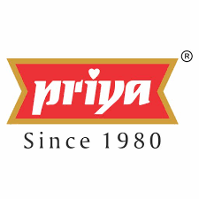

* 1. Constraints

The data availability is very low for training. Project to be executed in colab notebook.

* 1. Risks

Risks in detection are posed by data availability and hardware limitations.

1. Technical specifications
   1. Dataset

Images are collected from across the web for training. Youtube thumbnails and images are used to test the model.

* 1. Dataset samples

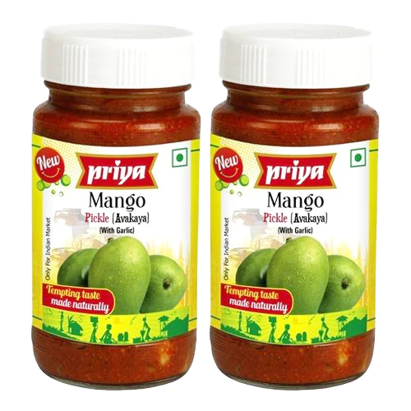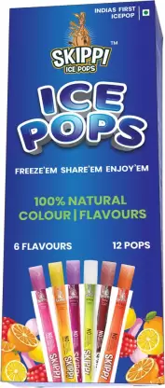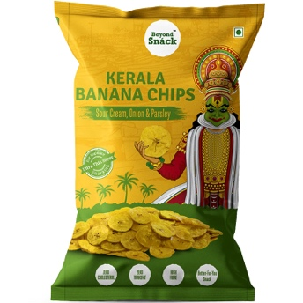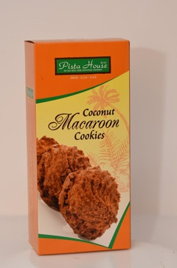

* 1. Data augmentation

Data is augmented by applying various techniques like shear, roataions, flips, contrast changes, cropping etc.

* 1. Annotation

Annotation is done online on roboflow platform.

2.5 Logging

Logging is done at every step. Tensorboard is used.

* 1. Exception handling

Exception handling is done at every step to address unforeseen and rare events.

* 1. Model

Yolov5s model has been used to detect brands.

* 1. Deployment

Deployment is done at client preferred cloud service (since multiple deployment options should be given).



1. Technology stack

|  |  |
| --- | --- |
| **Front end** | Postman with API |
| **Back end** | Cloud |
| **Deployment** | AWS/Azure/Google cloud |

1. Proposed solution

Yolov5s model will be used to detect brand logos. This can be further integrated with mechanism that collect images directly from advertising sites based on urls given.

1. Architecture

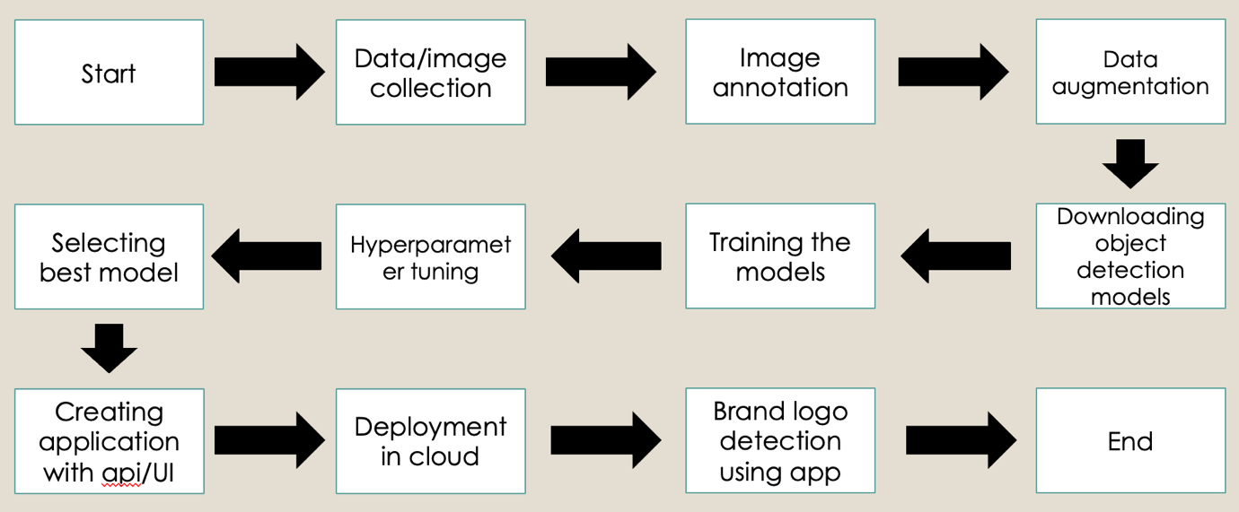

6 Conclusion

Brand logos can also be detected using object detection and existing models. This could significantly help companies in maximizing revenue, better targeting and reducing advertising costs.